
PGSO-PSMS: AN INTEGRATED WEB-BASED PROPERTY AND SUPPLY MANAGEMENT SYSTEM WITH BUSINESS ANALYTICS
FOR OPERTIONAL MONITORING AND
ASSET ACCOUNTABILITY

Jeremiah V. Jalando-on
Kristy L. Estillore
Daisy Grace M. Generale

A BSIT Capstone Project Proposal Submitted to the Faculty of Computing, Engineering, and Technology of Davao Oriental State University
In Partial Fulfillment of the Requirements for the Degree

BACHELOR OF SCIENCE IN INFORMATION TECHNOLOGY

MAY 2026

TABLE OF CONTENTS
TITLE PAGE
Title i
Table of Contents ii
List of Tables iii
List of Figures iv

CHAPTER 1: INTRODUCTION
1.1 Rationale of the Study 1
1.2 Purpose and Project Description 3
1.3 Objective of the Study 4
1.4 Significance of the Study 5
1.5 Scope and Limitations 6
1.6 Conceptual Framework 8
1.7 Definition of Terms 10

CHAPTER 2: REVIEW OF RELATED LITERATURE
2.1 Literature Map 12
2.2 Related Literature 13
2.3 Synthesis 17
2.4 Related Systems 18

CHAPTER 3: MATERIALS AND METHODS
3.1 Software Methodology 23
3.2 System Planning 25
3.3 System Analysis 31
3.6 System Design 39

LITERATURE CITED 41
LIST OF TABLES

TABLE PAGE
Table 1: Comparative Table 22
Table 2.1: Cost and Benefits Analysis Part-1 27
Table 2.2: Cost and Benefits Analysis Part-2 28

LIST OF FIGURES

FIGURES PAGE
Figures
Figure 1: Conceptual Framework of the Study 9
Figure 2: Literature Map 12
Figure 3:Web-Based Asset Management Interface 18
Figure 4: SNIPE-IT Asset Management System Interface 19
Figure 5: Computer Laboratory Asset System Interface 20
Figure 6: The Scrum Framework 23
Figure 7: PGSO-PSMS Work Breakdown Structure 30
Figure 8: PGSO-PSMS Gantt Chart 31
Figure 9: PGSO-PSMS Business Process Model and Notation 33
Figure 10: Landing Page 40

Figure 11: Login Page 40

Figure 12: Admin Dashboard 41

CHAPTER I
INTRODUCTION

  - Rationale of the Study
Inefficient operations are prevalent in organizations with unreliable manual and fragmented asset management systems (Abdelmoti et al., 2025). Parvathi et al. (2025) noted that while manual record-keeping is still prevalent in many institutions, it often leads to data duplication, lag time between data entry and updates, and challenges in ensuring data accuracy. Globally, asset management is still struggling with data integration and accessibility issues: the lack of data integration and interpretation of heterogeneous data reduces the possibility of effective information sharing and decision making among stakeholders (Gasbarri et al., 2024). Likewise, the Public Financial Management Committee of the Republic of the Philippines (2024) stated that fragmented and isolated systems cause inefficiencies in public sector processes, duplication of effort, and lack of transparency, among others, thus, digitalization and system integration are necessary in public sector processes.
These challenges are seen at the Provincial General Services Office (PGSO) of Davao Oriental in their approach to property and supplies management. Manual fragmented processes, hinder the tracking of progress in transaction of deliver and inspection. It's also difficult to know if requests are pending, approved, or completed. The lack of real-time monitoring and coordination causes delay in document processing such as Requisition and Issue Slip (RIS), Property Acknowledgement Receipt (PAR) and Inventory Custodian Slip (ICS). In addition, poor visibility into the status of a workflow and finding bottlenecks will impact operational efficiency. Not having a system to keep track of where, how, and by whom assets are being used, and the condition of the assets is also a concern for asset accountability.
The implementation of traditional asset tracking mechanisms is straightforward since it is based on manual registers or spreadsheet applications, but it has some drawbacks in terms of structural limitations, no validation constraints, no audit trail, and no ability to be used concurrently by multiple users, which in turn does not support end-to-end process integration and the visibility of the process across organizational activities. (Deokar et al., 2026; Parvathi et al., 2025). This has resulted in ineffective system coordination and transaction monitoring, impacting the performance of the system (Kashif & Chowdhury, 2024).
Furthermore, although digital capabilities have already been introduced to existing asset management systems, business analytics features like reporting, data visualization, and dashboards are still underutilized, limiting the systems' ability to convert collected data into actionable information for monitoring operations, tracking assets' accountability, and making informed decisions (Brasen & Tambo, 2025). Storing data in many systems does not effectively leverage the data for real-time monitoring and performance analysis to support data-driven decision making (Rafati et al., 2025). In addition, integration and data processing difficulties hinder the success of data analytics in asset management settings (Oyeniyi et al., 2024).
In order to cover these gaps, this study proposes developing a more comprehensive web-based asset management system that goes beyond its current functionality and will include workflow tracking as well as business analytics, comprising of visual reports and real-time dashboards. These features are designed to help in the improvement of the operational monitoring, process transparency, and to assist in the data-driven decision-making process, particularly for the Provincial General Services Office (PGSO) of Davao Oriental
1.2 Purpose and Project Description
This project aims to develop an integrated Property and Supply Management System (PGSO-PSMS) for the Provincial General Services Office (PGSO) to digitize delivery receiving, inspection, stock inventory, asset recording, repair tracking, and document processing within one single platform. The proposed system starts once the procured items are delivered and officially received by the Provincial General Services Office (PGSO). It does not cover the Purchase Request (PR), approval workflows, bidding procedures, and procurement processing. The system maintains real-time asset assignment, condition, location and asset maintenance records to enhance workflow monitoring, operational transparency and asset accountability.
The proposed system will apply descriptive analytics through dashboards and reports showing inventory status, available and low-stock supplies, delayed transactions, workflow status, repair records, asset conditions, and monthly or quarterly supply issuance for operational monitoring and evaluation. It will also apply prescriptive analytics by providing recommendations for replenishment of low-stock supplies, repair or disposal of damaged assets, reassignment of underutilized assets, and suggested supply quantities for yearly or quarterly PPMP preparation based on historical inventory and supply issuance records. Besides, QR code is used for better asset tracking and monitoring.

1.3 Objective of the Study
The proposed project aims to improve operational monitoring and asset accountability in the Provincial General Services Office.
Specifically, this project aims to:
- Digitize the receiving of delivered items, inspection, inventory recording, repair monitoring, and document processing of property and supplies.
- Manage inventory and ensure asset accountability by monitoring asset assignment, location, condition, maintenance history, and responsible personnel.
- Track repair and maintenance activities of assets by recording repair history, usability status, and damaged assets.
- Apply descriptive analytics through dashboards and reports that show inventory status, available and low-stock supplies, delayed transactions, workflow status, repair records, asset conditions, quarterly supply issuance for monitoring and evaluation to be use for decision making.
- Implement prescriptive analytics to recommend replenishment action for low-stock items, replacement or disposal of any damaged assets, re-assignment of items not in use and suggested quantities of supplies for annual or quarterly PPMP preparations based on inventory and supply issuance history.
- Enhance the asset tracking and monitoring by using the QR code-based asset identification and scanning system.

User Evaluation based on ISO/IEC 25010 Standards
The proposed PGSO-PSMS will be evaluated from the user point of view by applying the software quality model ISO/IEC 25010. PGSO personnel will conduct a user evaluation form and actual system testing to evaluate the system. The outcomes of the evaluation to be used for the effectiveness of the system in supporting operational monitoring, improved asset accountability and overall system performance.

1.4 Significance of the Study
The proposed system, PGSO-PSMS, will benefit the Provincial General Services Office by improving the efficiency, transparency, and accuracy of property and supply management processes. By replacing manual and fragmented processes with an integrated web-based system, it allows faster transaction processing, organized record management, improved workflow monitoring, and better asset accountability. The study will be significant to the following stakeholders:
PGSO personnel. The system would streamline and enhance the management of property, supplies, and repairs by PGSO staff by providing a single location for inventory and tracking, monitoring repairs, and processing documents. It also enables operational monitoring and decision making with dashboards and reports that provide information on inventory status, delayed transactions, repair records, PPMP preparation, inventory issuance and recommendations for replenishment, repair, disposal, reassignment of inventory based on past transactions.
Assigned Employee. The system will allow end users or employees to view their assigned and archived assets through a centralized platform. It also allows them to request transfer of assets, request new supplies or assets, and monitor the status of their requests. This improves accessibility of records, transparency, and communication between employees and the PGSO.
For future research, this study serves as a reference for developing integrated systems. It provides insights into combining operational monitoring, asset management, and analytics, which can be further improved or applied in other organizations
1.5 Scope and Limitations
The project focuses on the development and implementation of an integrated web-based Property and Supply Management System (PGSO-PSMS) for the Provincial General Services Office (PGSO).
The scope of the study includes the following:
- The system starts once procured items are delivered to the PGSO and received by authorized personnel.
- The system manages delivery receiving, inspection, inventory recording, asset assignment, repair monitoring, and document processing of property and supplies.
- The system supports operational monitoring by tracking transaction progress, document status (pending, approved, released), workflow steps, and delays.
- The system monitors asset assignment, condition, location, maintenance history, and responsible personnel to strengthen asset accountability.
- The system allows end users or employees to view assigned and archived assets, request transfer of assets, request new assets or supplies, and monitor request status.
- The system uses QR codes for easier asset identification, tracking, inventory checking, and monitoring.
- The system supports uploading and storing asset images and related documents such as Requisition and Issue Slip (RIS), Acceptance and Inspection Report (AIR), Property Acknowledgement Receipt (PAR) and Inventory Custodian Slip (ICS) forms.
- The system applies descriptive analytics through dashboards and reports showing inventory status, low-stock supplies, delayed transactions, workflow status, repair records, asset conditions, and monthly or quarterly supply issuance for operational monitoring and evaluation.
- The system applies prescriptive analytics during the inventory monitoring and reporting process by analyzing historical inventory transactions, supply issuance records, stock levels, asset condition, repair history, and asset utilization. Based on predefined decision rules and threshold values, the system generates recommendations for replenishing low-stock supplies, repairing or disposing of damaged assets, reassigning underutilized assets, and suggesting supply quantities for quarterly PPMP preparation.
- The system supports centralized encoding and updating of existing and newly acquired assets.
- The encoding mechanism for existing assets begins with authorized PGSO personnel accessing the uploaded PAR, ICS, AIR, and Excel records as reference. Asset details are manually encoded into the system, where automatic required-field validation, property number uniqueness checking, data format validation, and record verification are performed before the asset record is committed to the centralized database and assigned a unique QR code.
Meanwhile, the study is subject to the following limitations:
- The system does not include Purchase Request (PR) creation, approval workflows, bidding procedures, and procurement processing.
- The system is limited to PGSO personnel and authorized end users only.
- The system is web-based only and does not include mobile application support.
- The system does not integrate with external government systems or databases.
The accuracy of reports and recommendations depends on the correctness of encoded data and availability of internet connection
1.6 Conceptual Framework
As shown in Figure 1, the conceptual framework of the PGSO-PSMS follows the Input-Process-Output (IPO) model, where procurement, delivery, inspection, inventory, asset, and user data serve as inputs. These are processed through system functions such as authentication, transaction tracking, workflow monitoring, document processing, and business analytics. The system generates outputs including real-time dashboards, reports, generated documents, and analytical insights that support operational monitoring and decision-making, while feedback ensures continuous system improvement.
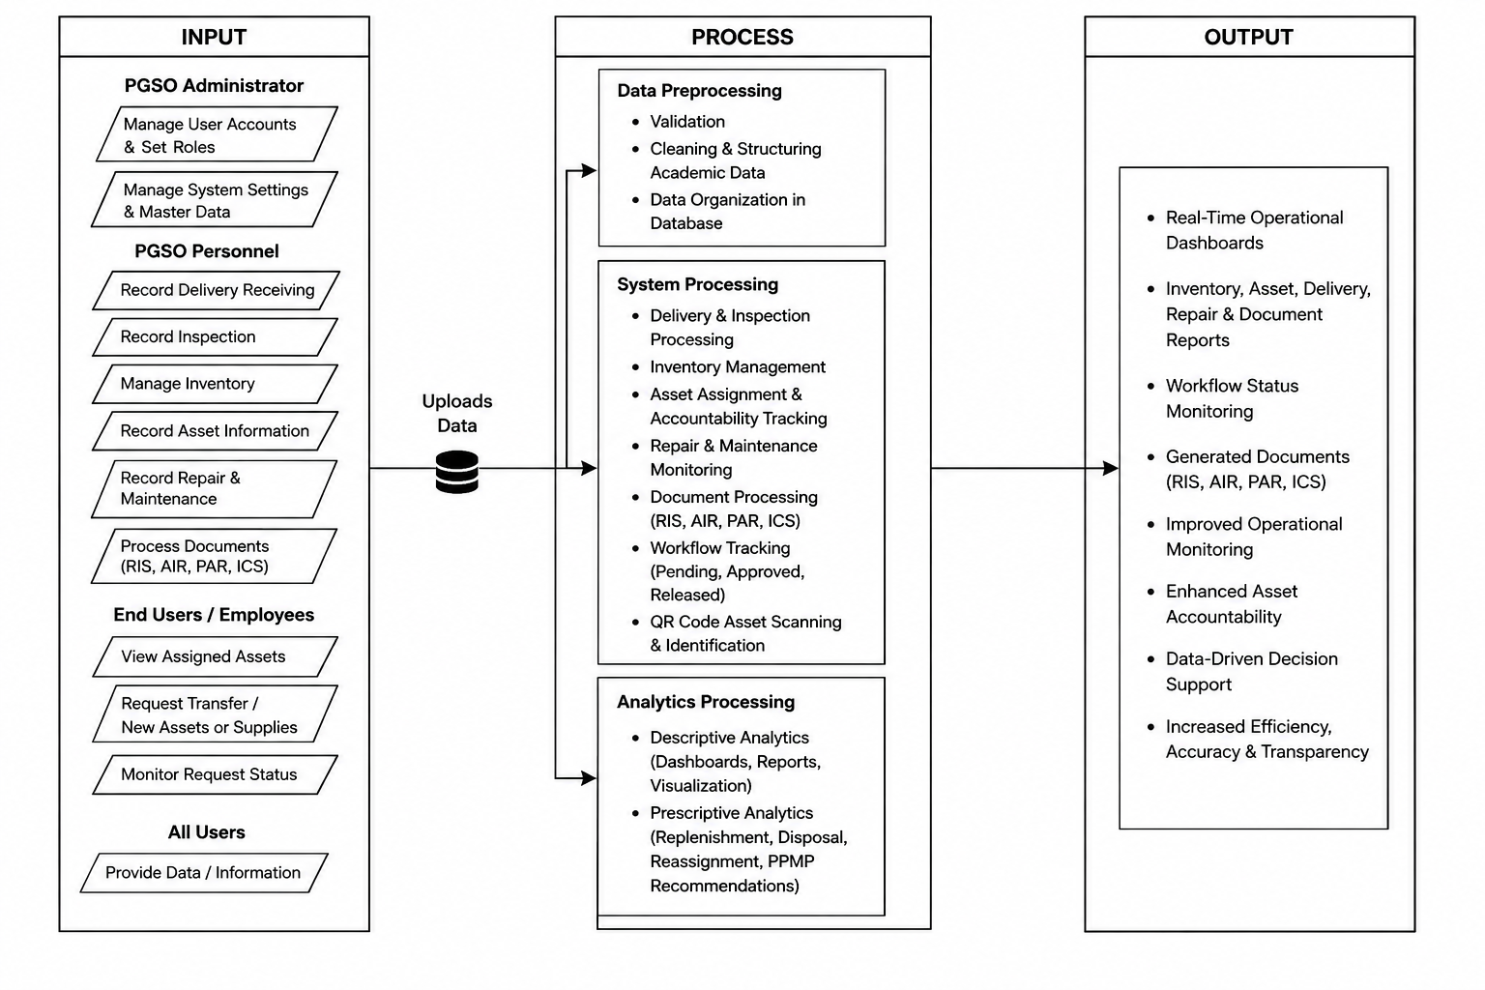
Figure 1. Conceptual Framework of the PGSO-PSMS System

1.7 Definition of Terms
For the purpose of this study, the following technical terms were used and defined to serve as a reference to the readers.
Asset Accountability | The process of assigning responsibility for assets to specific personnel and tracking their custody, location, condition, and usage within the system.
Business Analytics | The use of system data to analyze transaction performance, identify delays, monitor asset usage, and track repair patterns to support decision-making.
Delivery | The process of receiving items and verifying whether deliveries are complete or partial before proceeding to inspection.
Document Processing | A system function that manages and tracks documents such as Requisition and Issue Slip (RIS), Acknowledgement and Inspection Report (AIR), Property Acknowledgement Receipt (PAR), and Inventory Custodian Slip (ICS), including their status from preparation to release.
Inventory | Refers to the recording, monitoring, and management of property and supplies within the PGSO-PSMS, including their quantity, condition, location, and availability .
Operational Monitoring | The tracking of transaction progress, workflow status, and delays across delivery receiving, inspection, inventory, repair, and document processing.
Property and Supply Management System (PGSO-PSMS) | The proposed web-based system that integrates property and supply processes, operational monitoring, asset accountability, and business analytics for the PGSO.
Repair | The process of maintaining and restoring assets to a serviceable condition, including tracking repair history.

CHAPTER II
0
REVIEW OF RELATED LITERATURE
2.1 Literature Map
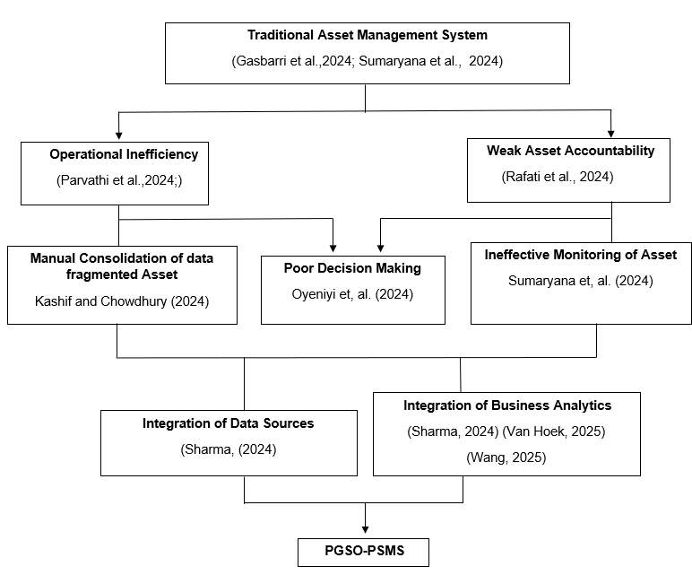
This literature map presents related concepts and studies on asset management, inventory management, and information systems relevant to the Provincial General Services Office (PGSO). It serves as a foundation for understanding how technology can improve asset monitoring and office operations.

Figure 2 Literature Map

2.2 Related Literatures
Operational Inefficiency and Weak Asset Accountability
Traditional asset management faces challenges in many organizations, as data is fragmented and siloed, residing on various platforms with poor interoperability (Gasbarri et al., 2024). This situation involves teams having to manually gather data on assets, resulting in delays, inconsistencies, and inefficiency in operations. In addition, poor coordination between departments and obsolete inventory of assets is a major factor in the poor utilization of resources and accountability in local government units, as explained by Sumaryana et al. (2024), with regard to the fragmented governance structure. Gasbarri et al. (2024) also found that traditional asset management techniques do not include real-time data and the current state of assets, which makes it hard for companies to track and manage assets. This was corroborated by Parvathi et al. (2025) who argued that manual and spreadsheet systems lead to additional delays, redundancy, and human errors in handling asset-related transactions.
This disintegration is not only in various systems and processes, but also across them, leading to inefficiency and lack of accountability for organizations. According to Sumaryana et al. (2024), poor asset records and lack of current data prevent the effective planning and monitoring, thus leading to underutilization of assets and poor decision making. Gasbarri et al. (2024) highlighted how the lack of integrated systems poses difficulties for organizations in collecting data, analysing and interpreting asset information, and thus, their operational performance. Rafati et al. (2024) highlighted that the lack of data-driven and real-time monitoring systems makes it difficult for organizations to take proactive action when dealing with operational problems. Consequently, Parvathi et al. (2025) found organizations tend to react rather than prevent issues, resulting in ongoing inefficiency and inadequate asset oversight.
Problems with Existing Asset Management Systems
Parvathi et al. (2025) noted that most of the firms are still using the conventional asset management systems like offline manual records, spreadsheets, and individual applications without integration. Such systems involve repetitive data input, have a high risk of human error, and restrict information sharing between departments. Gasbarri et al. (2024) also pointed out that current asset management systems face challenges in managing multiple and large datasets, especially if the data is sourced from various and not connected systems. Consequently, these systems result in disjointed processes and data handling inefficiencies, impacting the performance of the entire system and organization's efficiency.
Kashif and Chowdhury (2024) also noted that legacy system integration, real-time processing capabilities, cybersecurity concerns, and user acceptance remain significant hurdles in implementing asset management systems. In addition, Oyeniyi et al. (2024) highlighted that the successful integration of technology and robust data management are essential for ensuring that asset management systems can provide real-time visibility, accurate monitoring, and optimize operational efficiency. In the local government setting, Sumaryana et al. (2024) mentioned that the lack of coordination, the lack of awareness of the assets and fragmented governance impedes efficient allocation of resources and underutilization of assets. These problems show the need for a centralized asset management system that can improve data accessibility, operational monitoring, asset accountability, and decision-making.
Integration of Asset Management Data Sources
Data sources for assets need to be integrated since asset records are typically linked to various activities like acquisition, use, maintenance and disposal (Sharma, 2024). Digital asset management needs a centralized repository, as it allows the organization to manage asset-related information more efficiently and control asset records better (Sharma, 2024). Another advantage of a centralized repository is that it makes it easier to deal with fragmented asset information as asset data is managed in a single system rather than in separate records (Sharma, 2024). Likewise Oracle 2026 said that Asset Lifecycle Management is a holistic approach for managing the physical and financial management of assets of an organization over their entire life cycle. It also highlighted that it enables organizations to have a “single source of truth” for their asset information, which minimizes asset reporting duplication and inaccuracies.
The data and information systems of asset management are used to manage data, flows of information, interfaces with systems, and logical data models related to the assets, they assist in asset management activities and decision-making processes (Institute of Asset Management 2024). This illustrates the need for integrated data handling as asset records are not standalone but linked to various processes that rely on accurate and timely information. Similarly, (Adams et al.,2008) reported that asset management systems are a way of connecting existing data sources to improve decision support; this is another justification for integrating individual asset records into a single system.

Implementation of Business Analytics in Operational Workflows and Asset Accountability
From the traditional cost cutting focus, strategic asset has shifted to a value creating focus, and the key motivator of such a shift has been the enhanced business analysis capabilities. With the advent of digitalization, enterprises produce vast amounts of procurement information daily, such as supplier quotations, price changes in the market, logistics information, quality inspection results, and so on. When these data are only processed manually, it is not only an inefficient process, but it is also difficult to find deep laws in them (Van Hoek, 2025). The business analysis platform can integrate the enterprise resource planning system, the supplier management system, and external market data sources to create a comprehensive view of procurement data (Wang, 2025).Cocciolo, Samaddar and Fazekas (2023) noted that the digitalization of public procurement systems enables governments to quantify and analyze asset data, particularly if data analytics tools are used to monitor and evaluate public asset.
Also, business intelligence tools can be relevant in asset management as they enable such asset data organization and present its information for monitoring and decision-making management. Di Giuda et al. (2024) created an asset management system based on BIM, GIS, and business intelligence tools for space management, occupancy assessment, and optimization strategies. Awan et al. (2021) emphasized big data analytics capability as a tool for decision making, delivering data insights from organizational data. This is where analytics becomes useful when the system doesn't just store data, but it converts that data into useful information that users can use.
The proposed PGSO-PSMS is intended to be a cohesive and unified system that can help address these gaps by providing a real-time operational monitoring system, improving asset accountability by tracking and reporting on assets, and using business analytics to aid in data-driven decision making. This is intended to make the system more efficient, eliminate manual and disjointed processes, and more effective and transparent asset management system for the organization.
2.3 Synthesis
From the literature and systems reviewed, operational inefficiency and weak accountability of assets are noted as common problems in the area of asset management. The main challenges that arise are related to asset management, operational monitoring, and accountability reporting systems, and they are mostly related to the lack of appreciation of the value of business analytics, weak tracking systems and manual systems. Consequently, organizations suffer from inefficient processes and inadequate asset tracking, delays, incorrect data, and inaccurate information.
There are existing systems that perform different functions like web asset management systems, laboratory systems, and SNIPE-IT, but these systems are independent of each other, and not integrated. This constraint hinders their capacity to enable complete operational monitoring, business analytics, and asset accountability.
Thus, there's a pressing need to have a system in one place which can merge asset management, operational monitoring, asset accountability, and business analytics. This gap needs to be addressed in order to increase efficiency, increase transparency and facilitate data-driven decision making. The need is the basis for the development of the proposed PGSO-PSMS which addresses the identified limitation in the existing asset management practices.

2.4 Related Systems
Web-Based Asset Management Information System
The Web Based Asset Management Information System is designed to manage the data of assets by centralizing it in one system. It can be used to track, maintain, classify and report assets. It optimizes efficiency by streamlining assets information and minimizing use of manual records like spreadsheets (Hardy et al.,2016) .
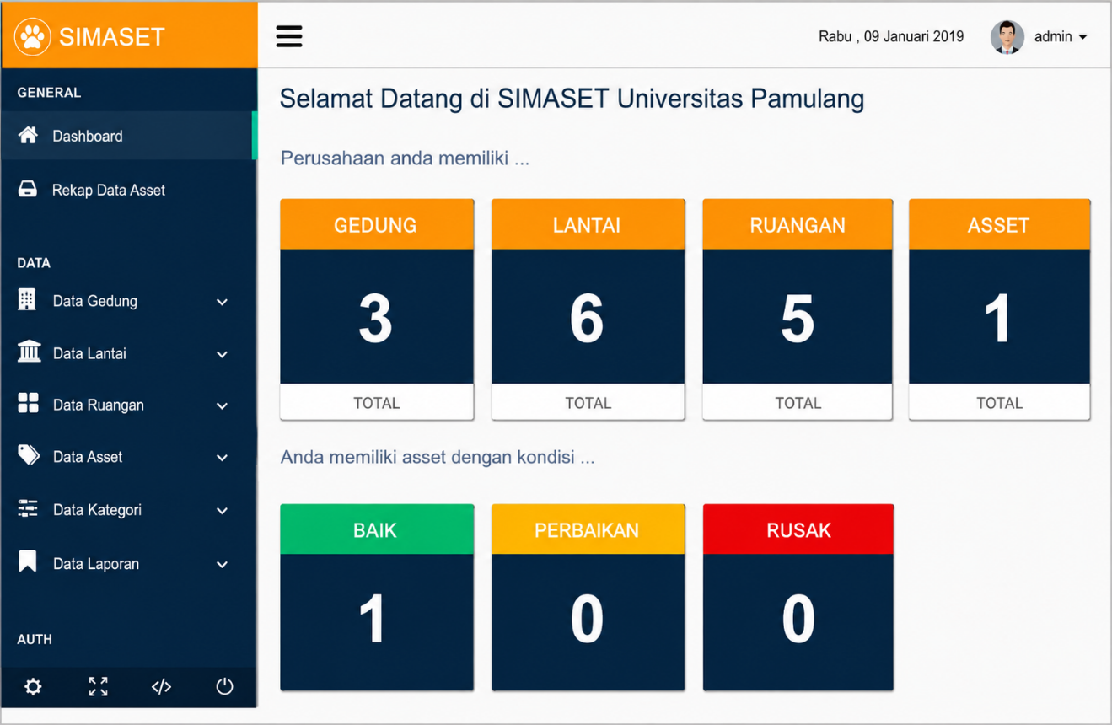
What makes this system powerful is that it can bring asset information together and boost efficiency. However, it's missing the built-in operating monitoring and sophisticated business analytics to assist with asset accountability.

Figure 3. Web-Based Asset Management Interface ( Hardy et al.,2016)

SNIPE-IT Asset Management System
SNIPE-IT is an open-source, web-based IT asset management system that helps to manage and track IT assets within an organization. It offers capabilities like asset inventory, lifecycle management, and asset assignment, enabling users to keep track of asset status and usage all in one place (Grokability, 2023).
The advantage of this system is the structured asset tracking and centralised data management. But it does not support the operational monitoring, nor does it offer advanced business analytics, making it less capable of supporting decision-making and overall asset accountability.
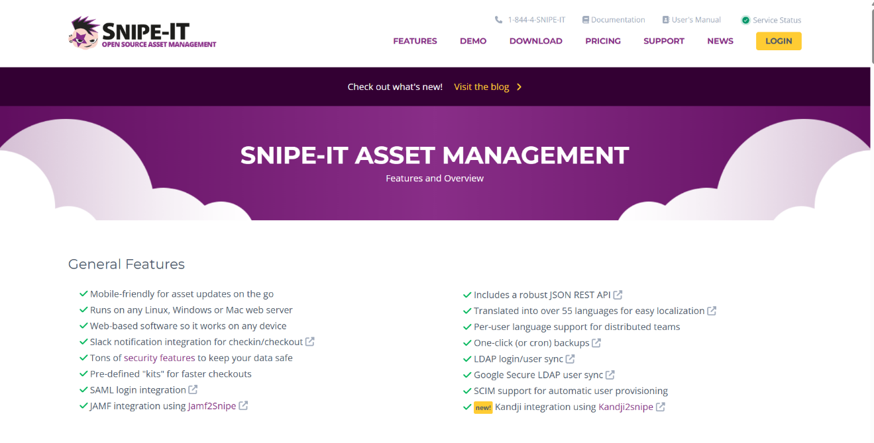
Figure 4. SNIPE-IT Asset Management System Interface (Grokability, 2023)

Computer Laboratory Asset Management Information System
The Computer Laboratory Asset Management Information System is a web-based system designed to manage assets in the Computer Laboratory, such as to track, record and monitor equipment. It enhances accuracy and efficiency by storing asset data digitally, and minimizing data loss (Awaluddin et al.,2020) .
The advantage of such a system is that it offers precise and structured asset records. It, however, is confined to a particular environment, and does not integrate with analytics and other operational monitoring, thus limiting its value in fixing inefficiency and accountability problems.
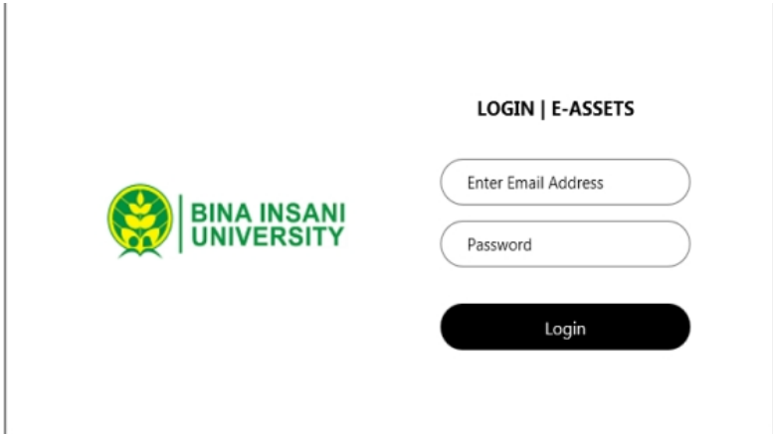
Figure 5. Computer Laboratory Asset System Interface (Awaluddin et al.,2020)

As shown in Table 1, all three existing systems and the proposed system share two common features, namely Asset Tracking and Inventory Management, which are considered the most basic functionalities of any asset management solution.
In terms of User Access Management and Report Generation, both the Web-Based Asset Management Information System and SNIPE-IT Asset Management System support these features, while the Computer Laboratory Asset Management Information System does not, indicating its limited administrative and documentation capabilities.
Notably, Real-Time Monitoring is absent in all three existing systems, highlighting a critical gap that the proposed PGSO-PSMS uniquely addresses. For the Check-in/Check-out System, only the Web-Based Asset Management Information System lacks this feature, while SNIPE-IT and the Computer Laboratory system both support it.
Regarding Asset Status Monitoring, the Computer Laboratory Asset Management Information System is the only system that does not offer this functionality. Similarly, the Notification and Alert System is only available in SNIPE-IT among the three related systems. Most significantly, Data Analytics and Dashboard is not present in any of the three existing systems, making it the most distinctive and advanced feature of the proposed PGSO-PSMS.

Table 1. Comparison Table
Features | Web-Based Asset Management Information System | SNIPE-IT Asset Management System | Computer Laboratory Asset Management Information System | Proposed System
Asset Tracking | YES | YES | YES | YES
Inventory Management | YES | YES | YES | YES
User Access Management | YES | YES | NO | YES
Report Generation | NO | NO | NO | YES
Real-Time Monitoring | YES | YES | NO | YES
Check-in/Check-out System | NO | YES | YES | YES
Asset Status Monitoring | YES | YES | NO | YES
Notification/Alert System | NO | YES | NO | YES
Data Analytics & Dashboard | NO | NO | NO | YES

CHAPTER III
MATERIALS AND METHODS

3.1 Software Methodology
The Software Development Life Cycle (SDLC) to be used in the development of the proposed Property and Supply Management System (PGSO-PSMS) in this project is Scrum Methodology (Sutherland & Schwaber, 2020). The Scrum model of development is divided into short iterations, called sprints, for which frequent feedback is received from users and features of the system are delivered. With this method, the researchers can fine-tune the system's needs as they see fit and make the system's capabilities better along the way. It is relevant to systems with multiple modules like delivery receiving, inspection, inventory, repair monitoring, document processing etc., iterative development, real time monitoring features, continuous improvement and user involvement.
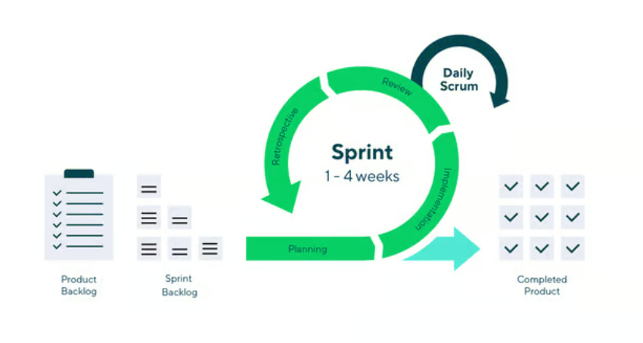
Figure 6. The Scrum Framework
Report (AIR), Property Acknowledgement Receipt (PAR), Inventory Custodian Slip (ICS) and Dashboard based reporting. The selected and prioritized tasks to be accomplished within a fixed period of 1 to 4 weeks are put into a list called a Sprint Backlog by the researchers. This will involve creating transaction processes, adding asset tracking capabilities, building document processing modules, and enhancing user interface. The team will also be responsible for assigning tasks and responsibilities, estimating task duration, and making sure that the tasks can be used by PGSO personnel.
The team will meet daily throughout the sprint to keep track of progress and to resolve any problems or issues that are found. The development process will include the implementation of system functionalities like asset assignment, tracking document progress (pending, approved, released), documents status and reporting. Data will be checked for accuracy prior to being placed in the system database. The team will be able to immediately address problems with the system's performance, data quality, user access and interface usability at the daily meetings. An operational version of the system will be created at the end of each sprint, including features like dashboards for transaction monitoring, asset tracking systems, and document management. The outputs will be shared for evaluation and feedback with PGSO personnel.
The team will have a review meeting after each sprint demonstration to analyze system performance and how to improve it. Feedback will be centd on the usability of the system, processing speed, accuracy of data and overall functionality. From this assessment, required changes will be determined and put back on the Product Backlog for the next iteration of the Sprint cycle. This is an iterative process which generates a continuous feedback loop, refining and enhancing the system continuously. This method guarantees the ultimate development of the PGSO-PSMS to be efficient, reliable, and suitable for effective property and supply management operations.
3.2 System Planning
The system planning phase is the basis for the development of the proposed PGSO-PSMS. During this stage, the researchers discuss the requirements of a system, determine the scope of the project, and establish the resources that are needed for the project: hardware, software and people. The features and functions of the system are planned considering the key processes like delivery receiving, inspection, inventory management, monitoring of repair, etc., and the document processing. This phase also deals with task organization, development approach preparation for feasibility, well structure and mapping of the system, to align with the needs of the Provincial General Services Office.

Feasibility Study
The feasibility study compares the viability of the proposed Property and Supply Management System (PGSO-PSMS) in terms of development, implementation and maintenance. It will help decide whether or not the system is viable, cost-effective and useful to the Provincial General Services Office (PGSO). The study concentrates on operational, technical and economic feasibility to determine if the system can be developed, implemented, and sustained effectively and addresses the identified organizational needs and improve overall efficiency.
Operational Feasibility
Since the proposed system is designed based on the real flow of work and task of PGSO personnel, it is expected that this will work in PGSO. It streamlines processes like tracking delivered items, inspections, inventory, repair monitoring, and document processing. Since these functions are already in the staff's workflow, it is likely that the system will be accepted and used by the staff as it will eliminate manual tasks and increase efficiency.
The current manual and fragmented transaction processes are challenging the PGSO to track the progress of transactions, detect delays, and keep accurate records. The difficulties can lead to inefficiencies and lack of visibility of the operations. Proposed system offers a solution to these challenges by offering a centralized platform for tracking, organizing data, and managing workflows in real-time.
In terms of organizational support, the interviewers conducted interviews with the PGSO management and staff to obtain some details about the existing procedures and functioning of the PGSO. Based on the interview, PGSO management confirmed that they will fully support the development and implementation of the proposed PGSO-PSMS since it targets the challenges that they identified in their property and supply management operations. The system will improve the operational monitoring process, better asset accountability and decision making in the Provincial General Services Office upon full development.
Economic Feasibility
The proposed PGSO-PSMS is economically feasible as the expected benefits outweigh the costs. The system is developed by the student researchers hence the development cost is minimal, the only costs are in deployment, maintenance and training. It is economical and is advantageous for the organization as it cuts down on manual work, reduces paper usage and enhances efficiency and productivity.
Table 2.1. Cost and Benefits Analysis Part-1
COST
Category | Estimated Budget
1. Requirements Gathering and Analysis | -
2. System Design | -
3. Implementation (Development)  3.1 Cloud/Database Services(Firebase – Annual | Php 12,000.00
4. Testing | Php 2,000.00
5. Deployment  5.1 User Training  5.2 User Evaluation | Php 3,000.00  Php 1,000.00
6. Maintenance  6.1 User Manual Development  6.2 Annual Maintenance and Updates | Php 2,000.00  Php 20,000.00
Total Cost | Php 40,000.00

Table 2.2. Cost and Benefits Analysis Part-2
BENEFITS
Time Savings: (3 users x 4 hours/week x 100x 4 weeks)
= Php 4,800.00
Monthly Savings: (3 users x 4 hours/week x Php 100 x 4 weeks)
= Php 4,800.00
Annual Savings: Php 4,8000.00 x 12
= Php 57,600.00
Total Benefits: Php 57,600.00
Return on Investment (ROI) = (Net Benefits – Total Cost)/ / Total Cost
= (Php 57,600.00 – Php 40,000.00) / Php 40,000.00
= 0.44 or 44%
Payback Period = (Cost Implementation / Monthly Savings)
= Php 40,000.00 / Php 4,800.00
=8.33 months

The economic feasibility of the proposed PGSO-PSMS is evaluated through a Cost–Benefit Analysis (CBA) to determine its practicality and value for implementation in the Provincial General Services Office. The total estimated project cost is ₱40,000.00, which includes expenses for cloud or database services, user training, user evaluation, user manual development, and system maintenance. Development-related activities such as requirements gathering, system design, and implementation do not incur direct cost since they are handled by the researchers.
The benefits of the system are measured through time savings, where it is estimated that three personnel can save approximately four (4) hours per week. Using an hourly rate of ₱100.00, this results in a monthly savings of ₱4,800.00 and an annual savings of ₱57,600.00. Based on these values, the system has a Return on Investment (ROI) of 44% and a payback period of approximately 8 months. These results indicate that the proposed system is cost-effective and economically feasible.
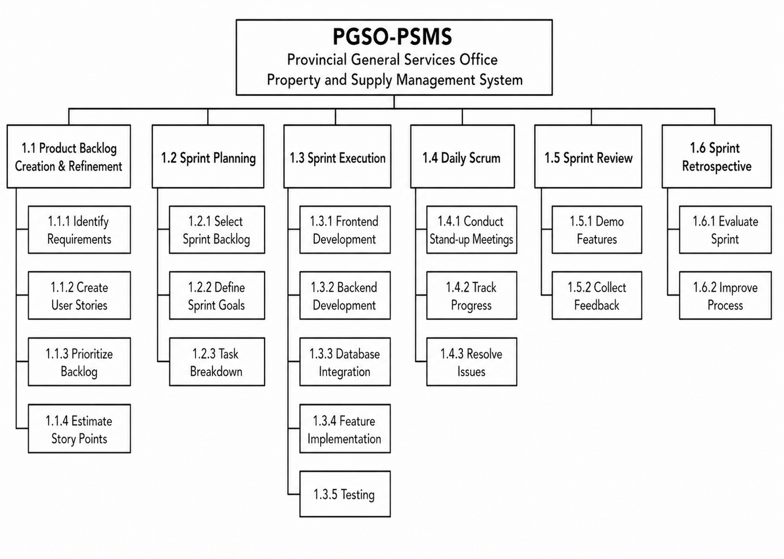
Figure 7. PGSO-PSMS Work Breakdown Structure

Gantt Chart
The Gantt chart in Figure 9 shows the project schedule for the PGSO-PSMS. It outlines the timeline of activities based on the Work Breakdown Structure (WBS). The project started in February 2026 with Requirements Gathering and Analysis. Was completed in March 2026. Then the System Design phase took place from March to April 2026. The other phases will be done later. The chart uses a time frame to show when each activity starts and ends making it easier to plan and monitor.
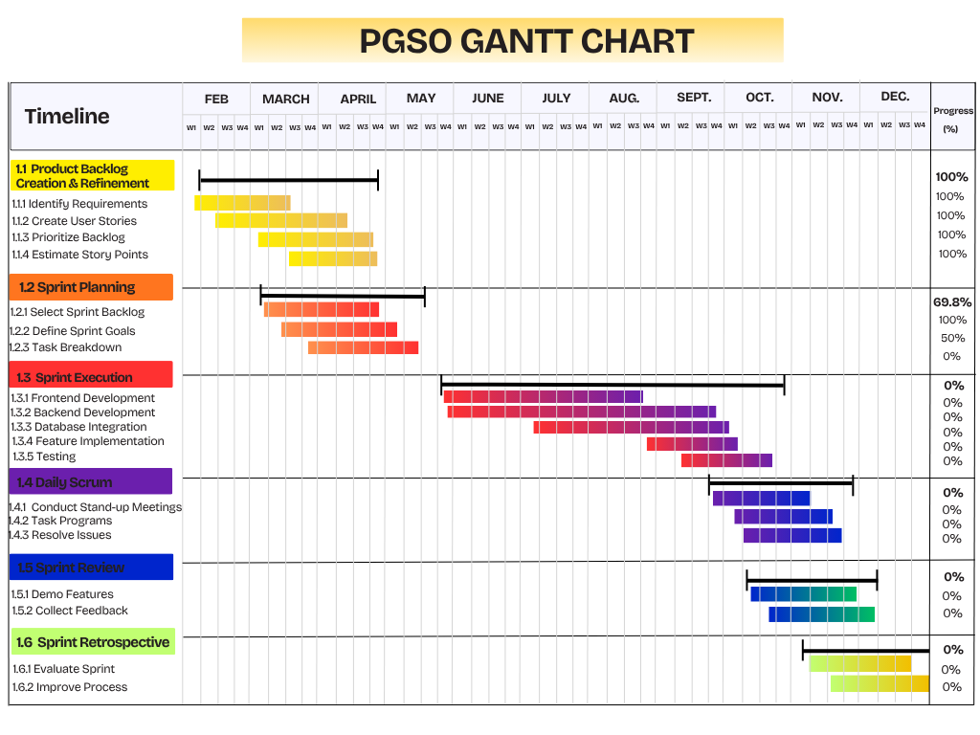
Figure 8. PGSO-PSMS Gantt Chart

System Analysis
In this study, the researchers analyze the current processes of the Provincial General Services Office (PGSO), including delivery receiving, inspection, inventory, repair monitoring, and document processing. The existing system relies on manual and fragmented methods, making it difficult to track transactions, monitor workflow status, and maintain accurate asset records, resulting in delays, errors, lack of transparency, and absence of centralized data. Based on this analysis, the system requires improvements such as centralized data management, real-time transaction tracking, asset monitoring, and efficient document processing, which serve as the basis for the development of the proposed PGSO-PSMS to enhance operational monitoring, strengthen asset accountability, and improve overall efficiency and decision-making.
Description of the Current System
At present, the Provincial General Services Office (PGSO) manages procurement and supplies using a mix of manual and semi-digital processes as shown in Figure 10. Things like getting deliveries inspecting items, managing inventory handling repair requests and processing documents are done using paper forms and separate records. This requires a lot of work and tracking making it time-consuming to monitor transactions. Because there’s no system it's hard to track the status of transactions and assets. This results, in lots of data, delays, errors and duplicated work, which hurts efficiency, accuracy and decision-making. All these problems show that an integrated and automated system is needed.

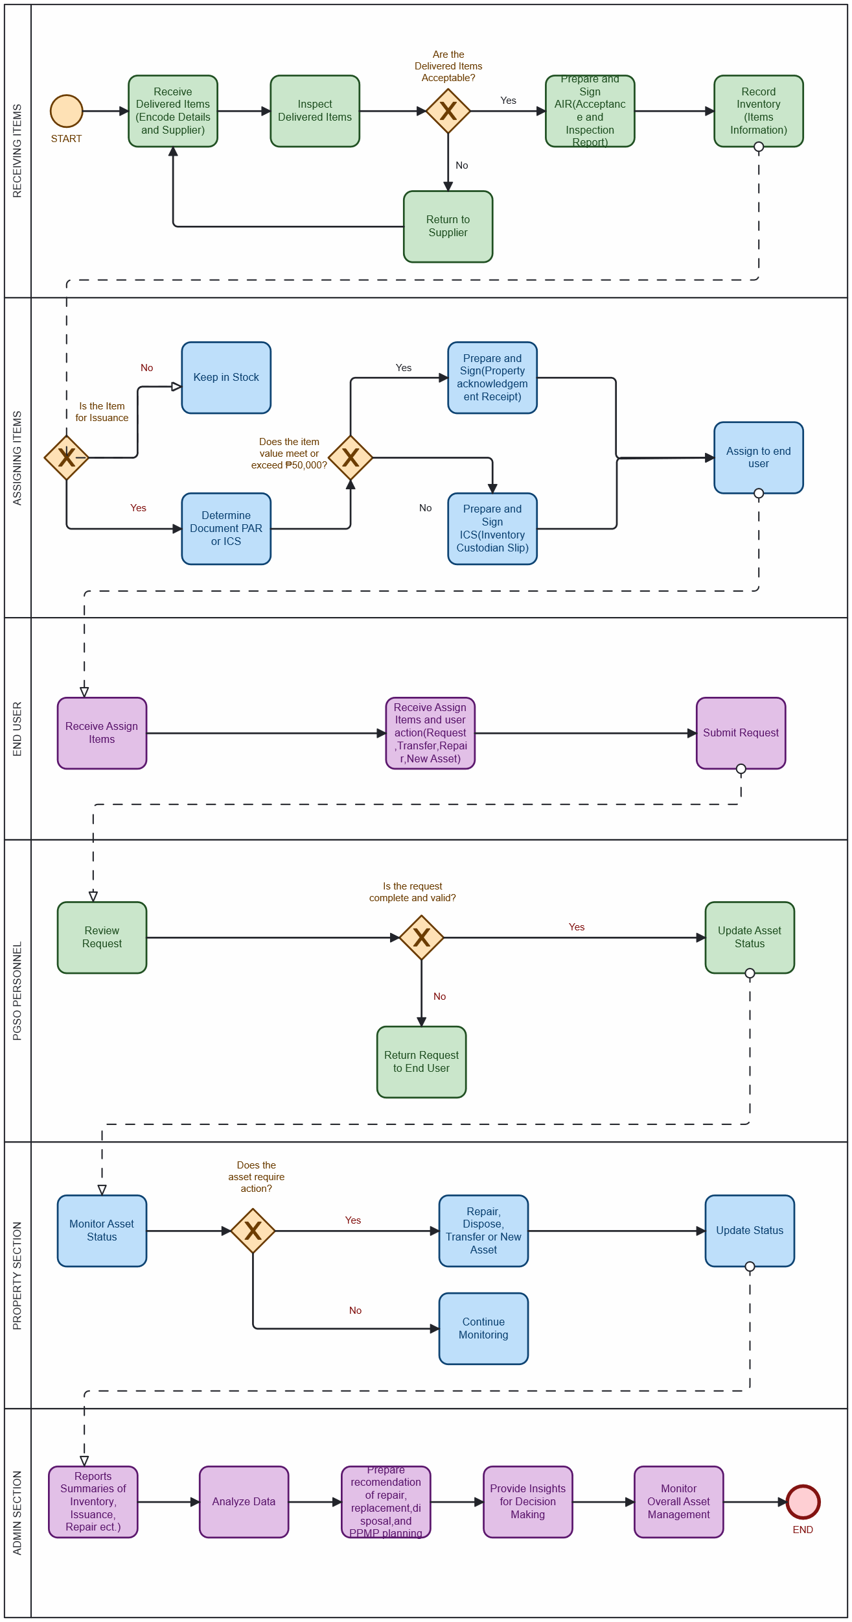

Figure 9. PGSO-PSMS Business Process Model and Notation

Requirements Specification
This section defines the functions and qualities that the proposed PGSO-PSMS must meet. It includes functional and non-functional requirements to support delivery, inspection, inventory, repair, document processing, operational monitoring, asset accountability, and business analytics.
- Functional Requirements
The system shall allow PGSO personnel to:
- manage delivery receiving, inspection, inventory recording, asset assignment, repair monitoring, and document processing of property and supplies;
- monitor delivery and inspection of items;
- manage inventory, including stock levels, condition, and location;
- record repair and maintenance activities;
- track documents such as Requisition and Issue Slip (RIS), Acknowledgement and Inspection Report (AIR), Property Acknowledgement Receipt (PAR), and Inventory Custodian Slip (ICS),
- assign and monitor assets for accountability;
- track workflow status (pending, approved, completed);
- generate inventory, delivery, inspection, repair, and document-based reports (RIS, AIR, PAR, ICS), including summary and analytical reports to support operational monitoring and decision making.
2. Non-Functional Requirements
- Performance The system should respond to user interactions within 5 seconds under normal operating conditions. Tasks such as submitting delivery and inspection records, processing documents like RIS, AIR, PAR, and ICS, and generating business analytics dashboards should be completed within a reasonable time without noticeable delays. This ensures that GSO personnel can perform their tasks efficiently and that the system can handle regular operations effectively.
- Scalability The system should be able to support a large number of users and manage growing records, transactions, and assets without experiencing major performance problems. As the Provincial General Services Office's operations and needs expand, it should continue to be effective and dependable.
- Portability The system should be accessible on any device, including desktop computers, laptops and tablets long as they have a major operating system like Windows, macOS or Linux. It should be accessible through a web browser without needing any extra software. This way GSO Personnel can use the system from any workstation in the Provincial General Services Office.
- Compatibility The system should be accessible on any device, including desktop computers, laptops and tablets long as they have a major operating system like Windows, macOS or Linux. It should be accessible through a web browser without needing any extra software. This way GSO Personnel can use the system from any workstation in the Provincial General Services Office.
- Reliability The system should always have consistent data. Records of asset assignments, inventory levels, inspection results and document processing should be correct and up to date. The system should prevent data loss, duplicate entries and inconsistencies. This is important for the Provincial General Services Office to have operational data.
- Maintainability The system should be built with modular and well-documented code. This will make it easy for future developers or system administrators to update and fix parts without disrupting the rest of the system. This will help the PGSO-PSMS long and continuously improve.
- Availability The system should be available. Working during regular office hours. Any scheduled maintenance or updates should be done outside of office hours to minimize disruptions. This will ensure that GSO Personnel can always access transaction records, asset data and monitoring features when they need to.
- Security The system should require login credentials to authenticate GSO Personnel before letting them in. All data, including asset records, delivery information and processed documents should be protected from access or modification. The system should manage sessions properly to keep data secure throughout each user session.
- Usability The system should be easy to use with an intuitive interface. GSO Personnel should be able to use it with training. All modules, including delivery, inspection, inventory, repair, document processing and analytics dashboards should be clearly. Easy to navigate. This will help personnel complete their tasks accurately and efficiently regardless of their experience.

Proposed Solution
The proposed PGSO-PSMS directly addresses the issues identified in the Provincial General Services Office (PGSO). The system reduces the reliance on manual methods by integrating delivery receiving, inspection, inventory recording, repair monitoring, and document processing into a single web-based platform. This minimizes data entry errors and eliminates repetitive manual encoding. To address the difficulty of monitoring transactions, the system provides real-time workflow monitoring, allowing PGSO personnel to track the status of each transaction whether it is pending, approved, or completed, and quickly identify delays and bottlenecks.
The system also improves asset accountability by monitoring asset assignment, location, condition, and the personnel responsible for each asset, ensuring that all assets are properly recorded and monitored throughout their lifecycle. In addition, the system tracks important documents such as the Requisition and Issue Slip (RIS), Acceptance and Inspection Report (AIR), Property Acknowledgement Receipt (PAR), and Inventory Custodian Slip (ICS) to reduce delays in document processing from preparation to release. Furthermore, the proposed system supports data-driven decision-making in inventory replenishment, repair or disposal of damaged assets, reassignment of underutilized assets, workflow monitoring, and annual or quarterly PPMP preparation. Through business analytics dashboards, reports, and recommendations, PGSO management can evaluate inventory levels, workflow performance, asset conditions, maintenance history, and supply issuance records to make timely and informed operational decisions. These analytics help PGSO management make informed decisions on inventory replenishment, repair or disposal of assets, asset reassignment, workflow monitoring, and PPMP preparation. This enables management to improve operational efficiency, strengthen asset accountability, and optimize resource allocation
Ethical Considerations
Data Storage and Feedback
- Hard and soft copies of answered questionnaires/forms gathered through Google Forms will be stored securely in password-protected devices and Google Drive accessible only to the researchers.
- Data will be retained only during the conduct of the study and will be permanently deleted or properly disposed of after completion.
- Research findings and system results will be presented to PGSO personnel through reports, presentations, and system demonstrations.
Benefits of the Participants
- The proposed PGSO-PSMS will help improve transaction monitoring, inventory management, asset tracking, and document processing efficiency within the PGSO.
- The study may support better operational decision-making and serve as a reference for future studies related to asset management systems and business analytics.
Risk Assessment
- Possible risks include unauthorized access to confidential office records and data loss during data gathering and storage.
- All collected data will be treated confidentially and secured through password-protected storage and limited access only to the researchers.
Selection of Participants
- Permission and consent will be secured from the PGSO management and personnel before conducting interviews, observations, and system evaluation.
- Participants will include PGSO personnel involved in receiving delivery, inspection, inventory, repair monitoring, and document processing.
- Personnel not directly involved in property and supply management operations will not be included in the study.
- Participants may withdraw from the study at any time without penalty.
- The researchers declare that there are no financial or personal conflicts of interest related to the study.

3.6 System Design
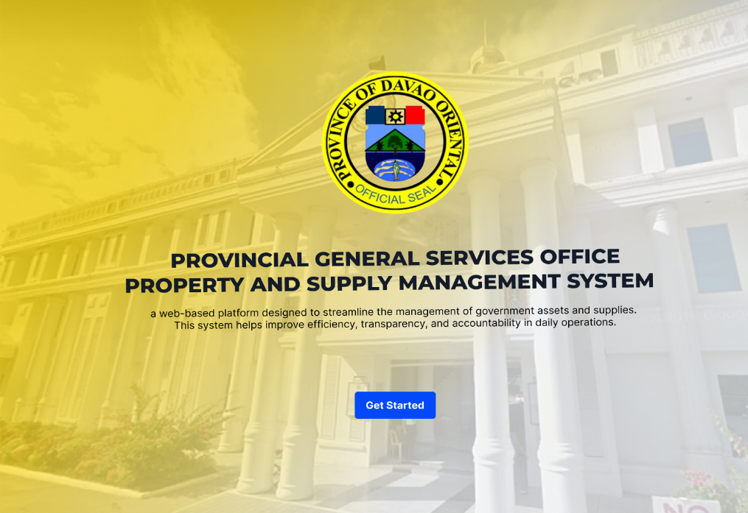

Figure 10. Landing Page

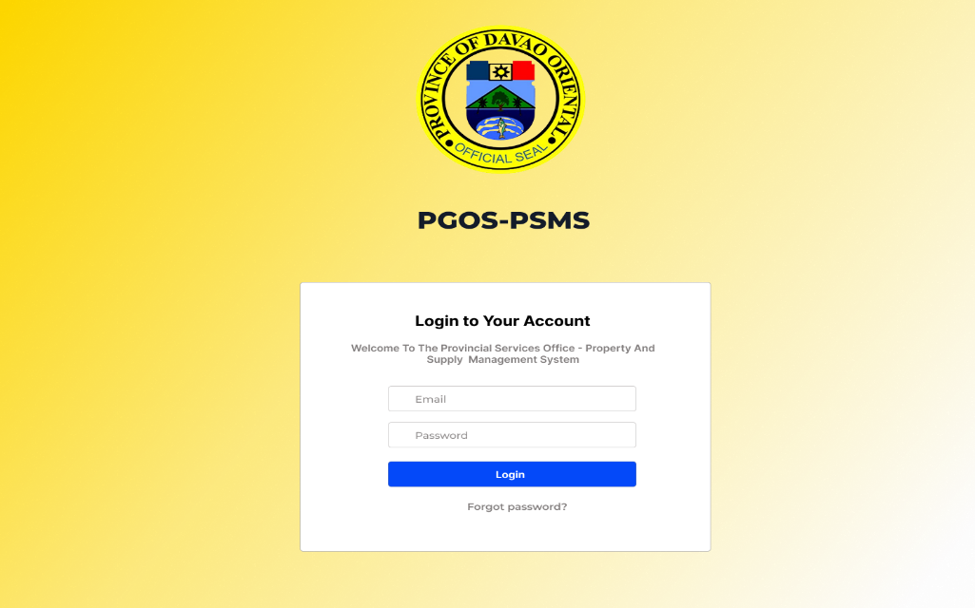

Figure 11. Login Page

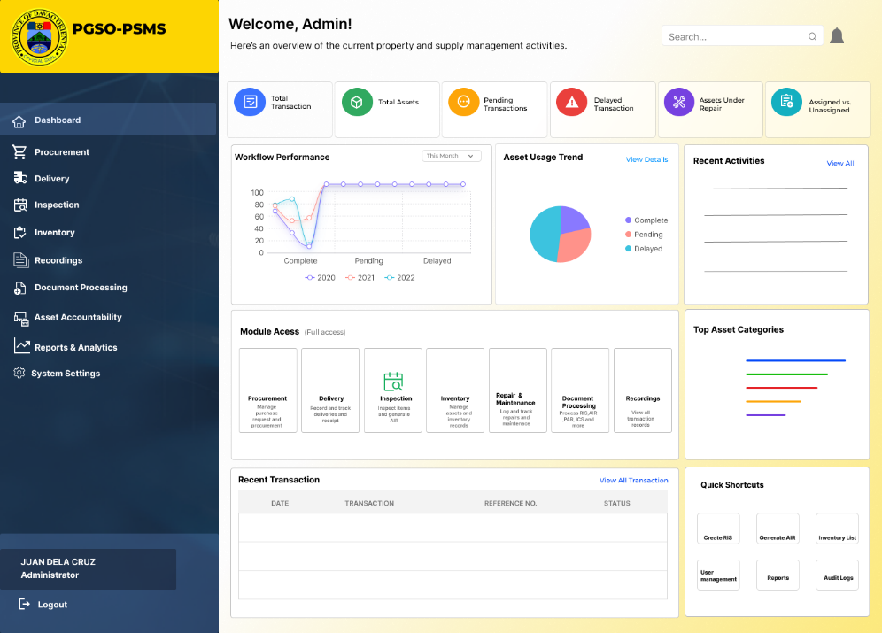

Figure 12. Admin Dashboard

LITERATURE CITED:
Abdelmoti, A. M., Shafiq, M. T., Rauf, A., & Khalfan, M. M. A. (2025). Challenges in asset management and digital twins: Industry insights. Buildings, 15(11), 1809. https://www.mdpi.com/2075-5309/15/11/1809
Adams, T. M., Bekkem, K. R., & Toledo-Durán, E. J. (2008). Synthesis of best practices for the development of an integrated data and information management approach. https://wisconsindot.gov/documents2/research/02-21integrateddata-f1.pdf
Ashar, M., Haliah, & Nirwana. (2025). ERP in public sector reform: A systematic literature review of technological, organizational, and institutional factors. Journal of Research in Social Science, Economics, and Management. https://jrssem.publikasiindonesia.id/index.php/jrssem/article/download/810/1493/8883
Brasen, L. P. H., & Tambo, T. (2025). Agile and asset management: Efficiency in decision-making for operational life-cycle projects in transmission system operators. Energy Research & Social Science, 129, Article 104383.
Cocciolo, S., Samaddar, S., & Fazekas, M. (2023). Government analytics using procurement data. In The Government Analytics Handbook. World Bank.
Cordeiro, R. (2024, September 20). Common IT asset management challenges and how to overcome them. Motadata. https://www.motadata.com/blog/it-asset management-challenges
Di Giuda, G. M., Meschini, S., Gasbarri, P., Accardo, D., Tagliabue, L. C., & Cacciaguerra, E. (2024). BIM, GIS and BI tools for a university asset management system supporting space management, occupancy evaluation and optimization strategies. Journal of Information Technology in Construction, 29, 1128–1155. https://doi.org/10.36680/j.itcon.2024.050
Effendy, M. Y., Nurninawati, E., & Setiyawan, A. A. (2022). Design and build a web-based asset management information system at PT Thamrin Telekomunikasi Network. Aptisi Transactions on Technopreneurship, 4(1), 47–57. https://doi.org/10.34306/att.v4i1.233
Gasbarri, P., Accardo, D., Cacciaguerra, E., Meschini, S., & Tagliabue, L. C. (2024). Supporting asset management with GIS and business intelligence technologies: The case study of the University of Turin. ISPRS International Journal of Geo-Information, 13(3), Article 65.
Institute of Asset Management. (2024). An anatomy of asset management. https://theiam.org/media/5615/iam-anatomy-version-4-final.pdf
International Monetary Fund. (2023). Digital solutions guidelines for public financial management. https://www.imf.org/-/media/files/publications/tnm/2023/english/tnmea2023007.pdf
Kashif, S. M., & Chowdhury, F. (2024). A comprehensive review of asset management systems: Trends, technologies, and future directions. Journal of Engineering and Computational Intelligence Review, 2(2).
Kusumojati, P. P., & Mediawati, E. (2024). Web-based asset management information systems in higher education. International Journal of Business, Law, and Education, 5(1), 398–411. https://doi.org/10.56442/ijble.v5i1.382
Mekimah, S., Zighed, R., Mili, K., & Bengana, I. (2024). Business intelligence in organizational decision-making: A bibliometric analysis of research trends and gaps (2014–2024). Discover Sustainability, 5, Article 532. https://doi.org/10.1007/s43621-024-00692-7
Oracle. (2026). Asset lifecycle management fundamentals. https://docs.oracle.com/en/applications/peoplesoft/financials-and-supply-chain-management/9.2.056/asset-lifecycle-management-fundamentals/asset-lifecycle-management-fundamentals.pdf
Oyeniyi, L. D., Ugochukwu, C. E., & Mhlongo, N. Z. (2024). IoT applications in asset management: A review of accounting and tracking techniques. International Journal of Science and Research Archive, 11(2), 1510–1525.
Parvathi, T., Jayasri, K., & Rajagopalan, R. (2025). Design and implementation of a web-based asset management system using MERN stack. International Journal for Research in Applied Science and Engineering Technology, 13(8). https://doi.org/10.22214/ijraset.2025.73802
Public Financial Management Committee of the Republic of the Philippines. (2024). Public financial management reforms roadmap 2024 to 2028: Propelling transformation: Achieving prosperity. Department of Finance. https://www.dof.gov.ph/wp-content/uploads/2024/09/PFM-Roadmap-2024-2028.pdf
Rafati, A., Tahavori, M., & Shaker, H. R. (2025). Data-driven reliability analysis of district heating systems for asset management applications: A review. Sustainable Cities and Society, 118, Article 106052.
Royal Institution of Chartered Surveyors. (2022). Strategic public sector property asset management (3rd ed.). RICS. https://www.rics.org/profession-standards/rics-standards-and-guidance/sector-standards/real-estate-standards/strategic-public-sector-property-asset-management-3rd-edition
Sharma, S. (2024). Digital transformation in IT asset management process. International Journal of Innovative Science and Research Technology, 9(6). https://www.ijisrt.com/assets/upload/files/IJISRT24JUN509.pdf
Sumaryana, A., Komara, S. R., & Pancasilawan, R. (2024). Rethinking local government asset management in Indonesia: Governance, planning, and policy evaluation. Journal of Contemporary Governance and Public Policy, 5(2), 217–232. https://doi.org/10.46507/jcgpp.v5i2.643
UNIKO Media Group. (2024, August 11). Business analytics: Using data to drive efficiency. Pomona Chamber of Commerce. https://pomonachamber.org/business-analytics-using-data-to-drive-efficiency/
Van Hoek, R. (2025). The future of procurement. In Leading procurement strategy: Driving value through the supply chain (p. 236).
Wang, X. (2025). Business analytics in strategic sourcing and supplier performance management within modern supply chains. Lecture Notes in Education, Arts, Management and Social Science, 3(9), 154–160. https://www.researchgate.net/publication/399080917_Business_Analytics_in_Strategic_Sourcing_and_Supplier_Performance_Management_within_Modern_Supply_Chains
Wan, U., Shamim, S., Khan, Z., Zia, N. U., Shariq, S. M., & Khan, M. N. (2021). Big data analytics capability and decision-making: The role of data-driven insight on circular economy performance. Technological Forecasting and Social Change, 168, Article 120766. https://doi.org/10.1016/j.techfore.2021.120766

